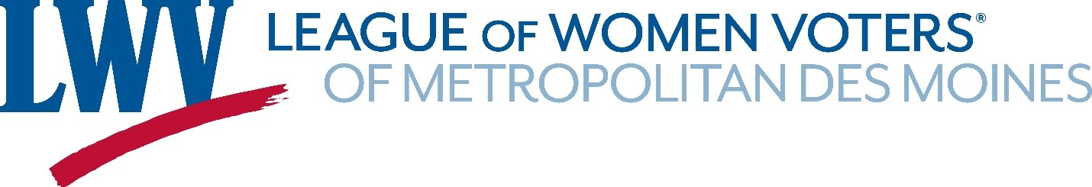
2025 ANNUAL MEETING AGENDA April 26, 2025
10 AM - Call to Order – Teresa Bomhoff, President
- Confirmation of quorum (at least 17)
- Announcement of any changes to the agenda
- No Bylaw changes recommended this year
- Appointment of Parliamentarian
- Appointment of Auditors for 2025 Annual Meeting Minutes
- Adoption of Minutes of 2024 Annual Meeting
10:05 Treasurers Report –Noreen O’Shea, Treasurer
- 2025-2026 Proposed Operating Budget with balances in Operating account
- 2025- 2026 Proposed Education Fund Budget with balances in Education account

10:15 Remembrance of Past Members – Karen Person, Membership
10:25 Affirmation of Amendments to Local Program – Mary Ellen Miller, Program

10:35 President’s Report – Teresa Bomhoff, President
10:40 Election of Officers and Directors – Teresa Bomhoff, President
- Appoint a nominating committee for next year’s annual meeting

10:50 Approval of Delegates
- Approval of voting delegates to the State Convention –- June 20 & 21
- Approval of voting delegates to the National Council – June 26-29
- Approval of 1 voting delegate to the UMRR Annual meeting – zoom, June 3 – 7 pm – Judy Peters
10:55 New Business
Noon - Luncheon - Participants go through potluck line

11:15 Introduction of Speaker – John Olsen
Speaker – Heather Jones-Brown

Noon - Adjournment

